The Manual Alphabet 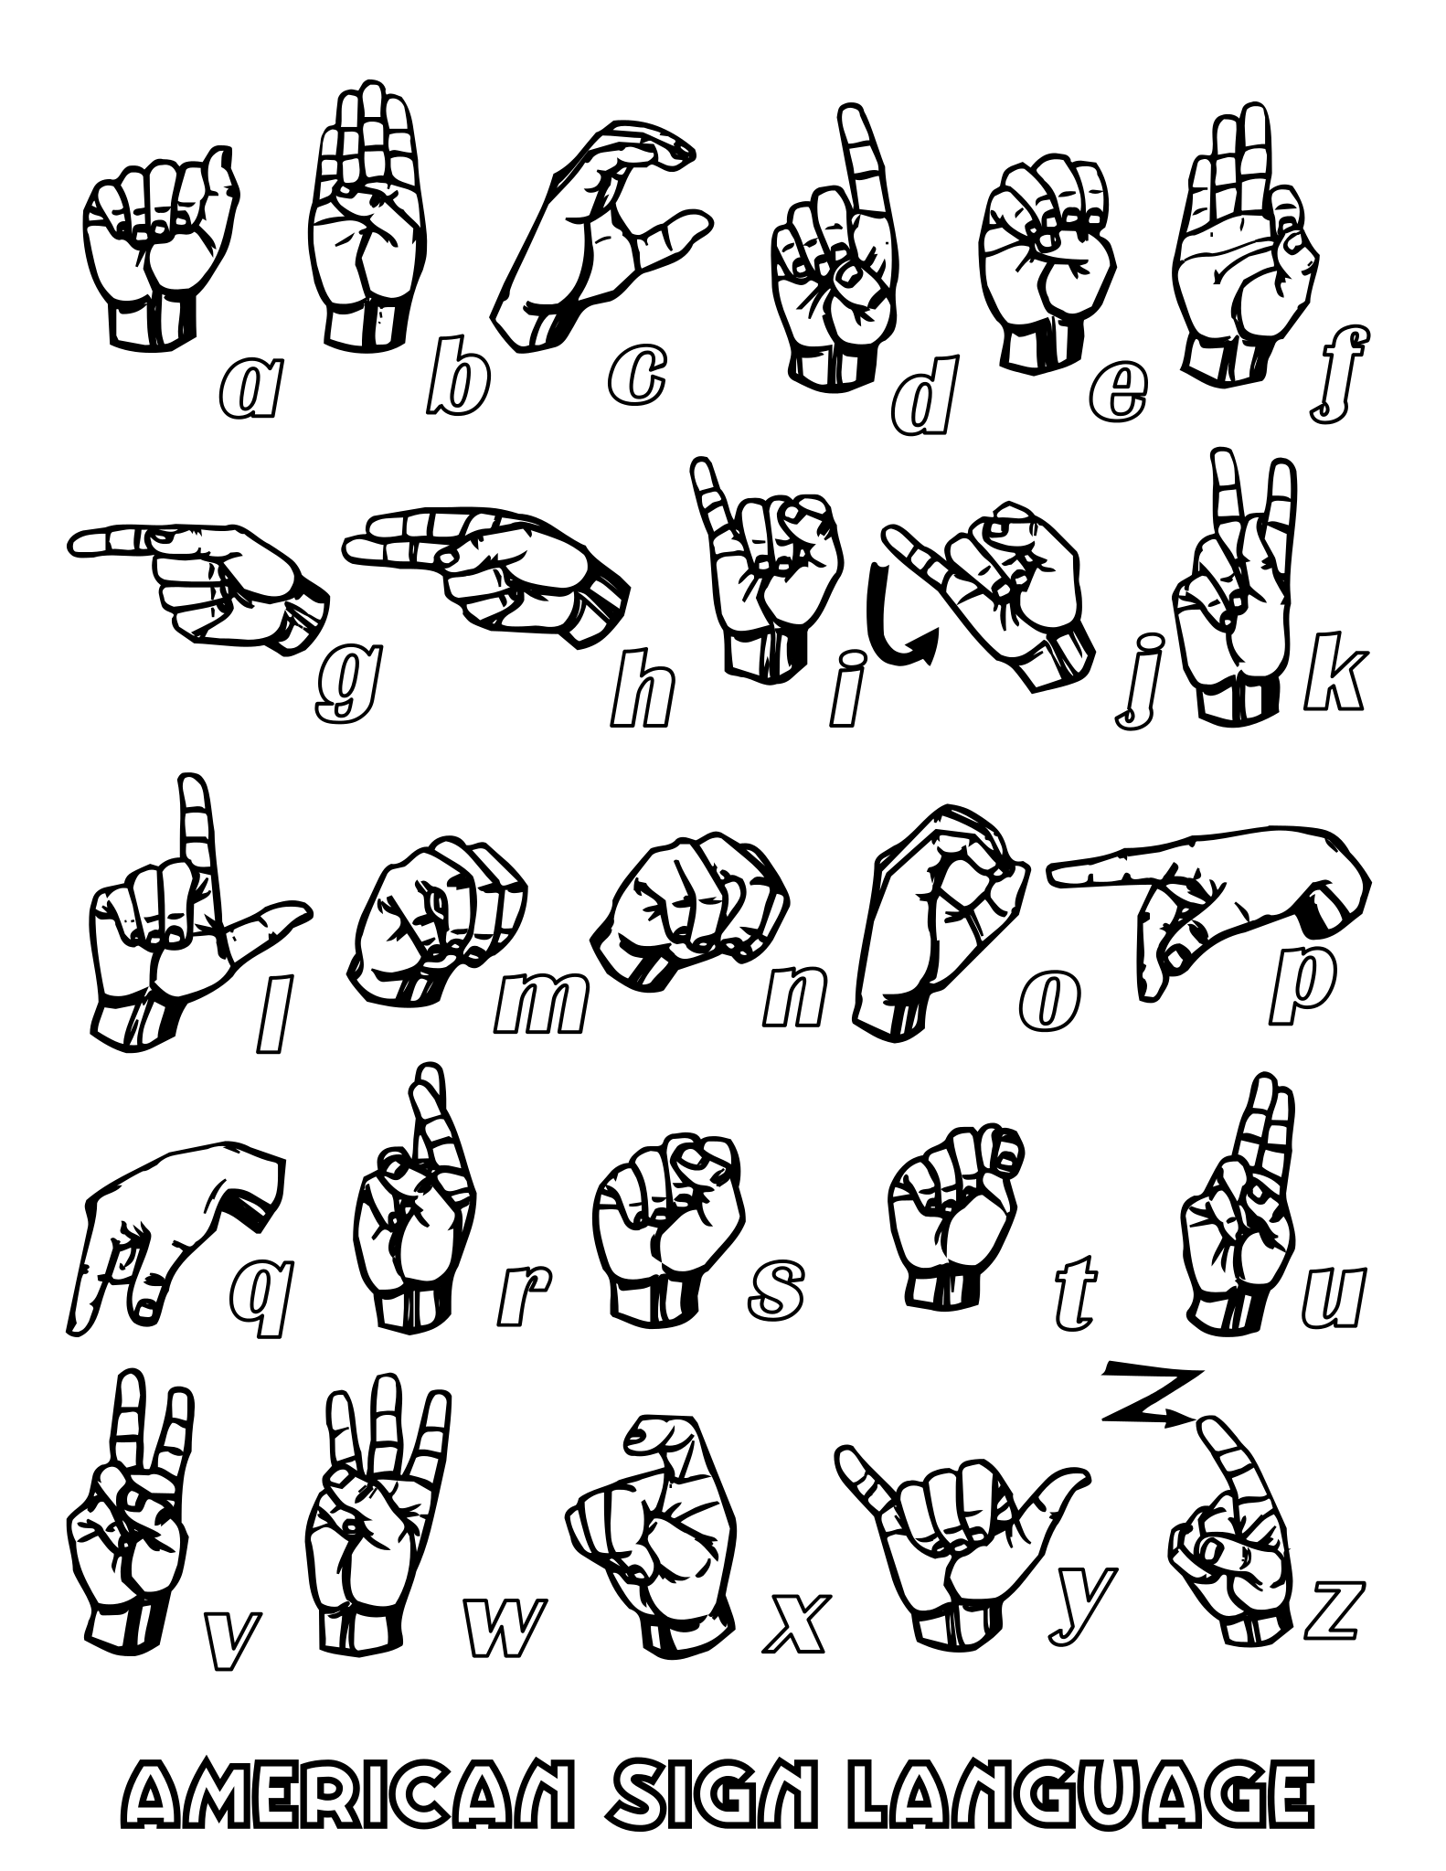

Numbers 1-9

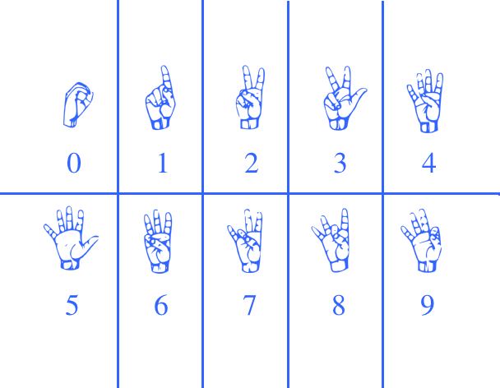

**Simple Words for starting-off:**

| **Yes** |  |
| --- | --- |
| **No** |  |
| **Help** |  |
| **Fingerspell** |  |
| **Bathroom** |  |
| **Again** |  |
| **Please** |  |
| **Thankyou** |  |
| **Sorry** |  |
| **Name** |  |
| **Home** |  |
| **Family** |  |
| **Work** |  |
| **Friends** |  |
| **Like** |  |
| **Deaf** |  |
| **Hard of Hearing** |  |
| **Hearing** |  |
| **Man** |  |
| **Woman** |  |

**ASL Sentence Structure:**

**TOPIC/COMMENT**

**Example:**

**STORE (Topic) I GO (Comment)**

*\*\*\*Structure your sentences as topic/comment unless you also have a time reference. In this instance the time reference would precede the Topic.*

**TIME REFERENCE/TOPIC/COMMENT**

**Example:**

**TODAY (Time Reference) STORE (Topic) I GO (Comment)**